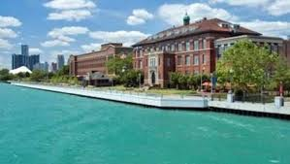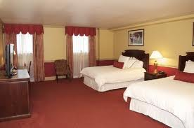

The team at Dandelion has created a platform for you to voice what and how things need to change in our mighty city. Become part of the conversation and compete to create the change we need in Detroit!

Visit our interactive [platform](http://gabbybryan8.wix.com/value#!home/mainPage).

**Dandelion Team**

Jason Lorimer

Jody Levy

Matt Wolf

Sara Greene

Charlie Cavell

Gabby Bryant

## Detroit DOES

## Project Showcase

SLEEPOVER DETROIT

Experience your own stay-cation in Detroit. The weekends can get hectic and oftentimes we just want to cut lose with our friends, without having to worry about the hassle of getting back home. Get to know SLEEPOVER DETROIT.

The Dandelion Doers

Dandelion News

2

Issue #1: July 22

Hilton Garden Inn Detroit Downtown

351 Gratiot Ave.

Detroit, MI 48226

313.967.0900

The Westin Book Cadillac Hotel

1114 Washington Blvd

Detroit, MI 48226

313.442.1600

MotorCity Casino

2901 Grand River Ave.

Detroit, MI 48201

866.752.9622

Prototype only. Not for redistrubtion

# Participating Downtown Hotels

Local hotels partnered with Dandelion to fulfill a demand that is largely unmet in Detroit. While tourism to Detroit from other states is not where hotels would like it to be, there are droves of people that come to Downtown, to enjoy the game and nightlife. It is more than a notion to get back home from Downtown late at night. The Dandelion team began to understand that Hotels have unused rooms that can be made available to those who are interested in the Nightlife of Downtown. By understanding the needs of Downtown goers and hotels, Dandelion was able to create a supply of rooms for people who can’t get enough of Detroit!

Roberts Riverwalk Hotel

1000 River Place

Detroit, MI 48207

313.259.9500

#### Project Showcase

(Continued)